Amendments to Enhance Beneficial Ownership Transparency and the Regulatory Regime for Corporate Service Providers Introduced in Parliament

**Introduction**

On 7 May 2024, the Companies and Limited Liability Partnerships (Miscellaneous Amendments) Bill ("**CLLPMA Bill**") and the Corporate Service Providers Bill ("**CSP Bill**") (collectively, the "**Bills**") were introduced in Parliament for their first reading. The Bills serve the following purposes:

* The CLLPMA Bill seeks to enhance the transparency of beneficial ownership of companies and limited liability partnerships ("**LLPs**"); and
* The CSP Bill seeks to enhance the regulatory regime for the Corporate Service Providers ("**CSPs**") sector.

The Ministry of Finance ("**MOF**") and the Accounting and Corporate Regulatory Authority ("**ACRA**") conducted a public consultation ("**Consultation**") on the draft Bills from 12 March 2024 to 25 March 2024. For more information on the Consultation, please see our earlier Legal Update [here](https://www.rajahtannasia.com/wp-content/uploads/2024/08/2024_03_21-Consultation-on-Amendments.pdf). MOF and ACRA have since responded to the feedback received in the Consultation ("**Consultation Response**"), indicating that the feedback received was generally supportive and that they would be proceeding with the proposals in the draft Bills. MOF and ACRA have also provided clarifications on some of the provisions in the Bills. The Consultation Response is available [here](https://www.acra.gov.sg/docs/default-source/default-document-library/legislation/listing-of-consultation-papers/annex-a--mof-s-and-acra-s-responses-to-key-feedback-on-the-draft-acra-(registry-and-regulatory-enhancements)-bill.pdf?sfvrsn=2cb5589c_3/annex-a--mof-s-and-acra-s-responses-to-key-feedback-on-the-draft-acra-(registry-and-regulatory-enhancements)-bill.pdf).

This Update highlights the key amendments introduced in the Bills and the clarifications provided in the Consultation Response.

[](https://www.linkedin.com/company/rajah-&-tann)

**Key Amendments in the CLLPMA Bill**

1. **Change in the definition of "Nominee Shareholders"**

The definition of "nominee shareholders" under the Companies Act will be amended to be a shareholder who fulfils ***either or both*** of the following criteria (rather than the current position, which requires fulfilling both criteria):

* The shareholder is accustomed or under an obligation whether formal or informal to vote, in respect of shares in the company or foreign company of which the shareholder is the registered holder, in accordance with the directions, instructions or wishes of any other person;
* The shareholder receives dividends, in respect of shares in the company or foreign company of which the shareholder is the registered holder, on behalf of any other person.

MOF and ACRA have indicated in the Consultation Response that intermediate holding companies in a group structure may be nominee shareholders if they fall within the amended definition.

1. **Nominee status of a nominee director/shareholder to be made publicly available**

Companies and foreign companies will be required to file all information kept in their register of nominee directors and register of nominee shareholders with ACRA, which will maintain such information in a central register. The nominee status of a nominee director/shareholder will be made publicly available, including adding the nominee status to business profiles purchased from ACRA. However, only public agencies may access the full information maintained by ACRA for the administration or enforcement of any written law.

Companies and foreign companies must lodge with the Registrar the prescribed information, including:

* All prescribed particulars contained in their register of nominee directors and register of nominee shareholders; and
* All updates to the registers that occur after the lodgement of those particulars.

Regarding the amount of time that would be provided to a company to file the required information, MOF and ACRA have indicated in the Consultation Response that ACRA will notify companies in advance on the timelines and process for such filing.

1. **Increase in fines for breaches relating to company registers**

The amendments will introduce the following new obligations, which carry a fine of up to S$25,000:

* A company or LLP must, at the prescribed frequency, check with every registrable controller in their register if there has been a change in their particulars or if their particulars are correct, by giving notice to every such controller. Failure to do so constitutes an offence.
* It is an offence for a person to fail to exercise due diligence, or to provide information that is false or misleading in a material particular, when responding to the Registrar or officers of ACRA in relation to the register of controllers, nominee directors or nominee shareholders (e.g. if the Registrar or officer exercises his power of enforcement to require the company/LLP to produce its register, or makes such inquiry as may be necessary to ascertain compliance with the relevant obligations).

The maximum fine will also be raised from S$5,000 to S$25,000 for offences pertaining to (i) the register of controllers, nominee directors, and nominee shareholders for companies; and (ii) the register of controllers for LLPs.

1. **Foreign companies to maintain register of nominee directors**

Under the CLLPMA Bill, foreign companies will also be subject to the requirement to maintain a register of nominee directors, thus aligning the treatment between local and foreign companies.

Further, MOF and ACRA have indicated in the Consultation that if a foreign company is exempt from maintaining a register of controllers, nominee directors, and nominee shareholders, they must declare the following to the Registrar as part of their annual filing:

* Whether they are exempted from maintaining the registers;
* If they are exempted, the category of exemption they fall under; and
* If they are not exempted, the location where their registers are maintained.

1. **Change in timeline for register of registrable controllers**

Companies and LLPs will be required to keep a register of registrable controllers starting on the date of incorporation or registration. Currently, this is only required within 30 days of incorporation or registration.

**Key Amendments in the CSP Bill**

1. **Registration of CSPs**

All business entities that carry on a business in Singapore of providing any corporate service must be registered with ACRA as a registered CSP even if they do not file transactions on behalf of their customers with ACRA.

MOF and ACRA have indicated in the Consultation Response that ACRA will publish guidance on the types of business entities that have to be registered as CSPs.

1. **Extension of risk obligations**

All registered CSPs will be required to carry out customer due diligence measures that will be prescribed by regulations. These measures relate to detecting and preventing the financing of proliferation of weapons of mass destruction, in addition to existing requirements for detecting and preventing money laundering and terrorism financing (collectively, "**AML/CFT/PF requirements**").

Currently, only Registered Filing Agents ("**RFAs**") are required to comply with requirements for detecting and preventing money laundering and terrorism financing. Further, RFAs are currently not required to comply with requirements for detecting and preventing the financing of proliferation of weapons of mass destruction.

1. **Criminal liability for CSPs and senior management for breach of AML/CFT/PF requirements**

Registered CSPs will be subject to criminal liability for breaches of their AML/CFT/PF requirements, as will their senior management for failure to ensure that the registered CSP complies with its AML/CFT/PF requirements. Currently, the senior management of RFAs are not subject to regulatory sanctions for breaches committed by their RFA.

The senior management referred to above are specified in the CSP Bill to be officers of the CSP or individuals involved in the management of the CSP and in a position to influence the conduct of the CSP in relation to the commission of the relevant offence.

1. **Requirements for nominee directors**

A person will only be able to act as a nominee director of a company if the appointment is arranged by a registered CSP. A person who breaches this requirement shall be liable to a fine not exceeding S$10,000 and, in the case of a continuing offence, to a further fine not exceeding S$1,000 for every day during which the offence continues.

Further, a registered CSP must not arrange for a person to act as a nominee director of a company unless he is satisfied that the person is fit and proper. In determining whether such person is fit and proper, the registered CSP must take reasonable steps to satisfy himself that the person is not disqualified from acting as a director of a company under any written law and must consider such other factors as may be prescribed in subsidiary legislation.

MOF and ACRA have indicated in the Consultation Response that:

* The amendments do not apply retrospectively to existing nominee director appointments made before the CSP Bill comes into force.
* The requirement for a registered CSP to be satisfied that the person whom it arranges to act as a nominee director is fit and proper has to be complied with *at the time of arrangement* for each company.

The full CLLPMA Bill is available [here](https://www.parliament.gov.sg/docs/default-source/bills-introduced/companies-and-limited-liability-partnerships-(miscellaneous-amendments)-bill-19-2024.pdf?sfvrsn=346a5608_1), and the full CSP Bill is available [here](https://www.parliament.gov.sg/docs/default-source/bills-introduced/corporate-service-providers-bill-18-2024.pdf?sfvrsn=856a5608_1).

For further queries, please feel free to contact our team members below.

Contacts

|  |  |  |  |  |  |
| --- | --- | --- | --- | --- | --- |
|  | |  |  | | |
|  |  |  |  |  | |
|  | **Abdul Jabbar Bin Karam Din**  Head, Corporate and Transactional Group  T +65 6232 0465  [abdul.jabbar@rajahtann.com](mailto:abdul.jabbar@rajahtann.com) |  |  | **Khairil Suhairee**  Partner, Corporate Commercial  T +65 6232 0571  [khairil.suhairee@rajahtann.com](mailto:khairil.suhairee@rajahtann.com) | |
|  | |  |  | | |
| Click [**here**](https://sg.rajahtannasia.com/our-work/practices/corporate-commercial) for our Partners in Corporate Commercial Practice. | | | | |
|  | |  |  | | |

Please feel free to also contact Knowledge Management at [eOASIS@rajahtann.com](mailto:eOASIS@rajahtann.com)

Our Regional Contacts

|  |  |  |
| --- | --- | --- |
| **Rajah & Tann Sok & Heng Law Office**  T +855 23 963 112 / 113  F +855 23 963 116  kh.rajahtannasia.com |  | **Rajah & Tann Myanmar Company Limited**  T +95 1 9345 343 / +95 1 9345 346  F +95 1 9345 348  mm.rajahtannasia.com |
|  |  |  |
|   **Rajah & Tann Singapore LLP**  **Shanghai Representative Office**  T +86 21 6120 8818  F +86 21 6120 8820  cn.rajahtannasia.com |  | **Gatmaytan Yap Patacsil Gutierrez & Protacio (C&G Law)**  T +632 8894 0377 to 79 / +632 8894 4931 to 32  F +632 8552 1977 to 78  www.cagatlaw.com |
|  |  |  |
| **Assegaf Hamzah & Partners**  **Jakarta Office**  T +62 21 2555 7800  F +62 21 2555 7899  **Surabaya Office**  T +62 31 5116 4550  F +62 31 5116 4560  [www.ahp.co.id](http://www.ahp.co.id) |  | **Rajah & Tann Singapore LLP**  T +65 6535 3600  sg.rajahtannasia.com    **R&T Asia (Thailand) Limited**  T +66 2 656 1991  F +66 2 656 0833  th.rajahtannasia.com |
|  |  |  |
| **Rajah & Tann (Laos) Co., Ltd.**  T +856 21 454 239  F +856 21 285 261  la.rajahtannasia.com    **Christopher & Lee Ong**  T +60 3 2273 1919  F +60 3 2273 8310  [www.christopherleeong.com](http://www.christopherleeong.com) |  | **Rajah & Tann LCT Lawyers**  **Ho Chi Minh City Office**  T +84 28 3821 2382 / +84 28 3821 2673  F +84 28 3520 8206  **Hanoi Office**  T +84 24 3267 6127  F +84 24 3267 6128  www.rajahtannlct.com |
|  |  |  |
| Rajah & Tann Asia is a network of legal practices based in Asia.  Member firms are independently constituted and regulated in accordance with relevant local legal requirements. Services provided by a member firm are governed by the terms of engagement between the member firm and the client.  This update is solely intended to provide general information and does not provide any advice or create any relationship, whether legally binding or otherwise. Rajah & Tann Asia and its member firms do not accept, and fully disclaim, responsibility for any loss or damage which may result from accessing or relying on this update. | | |

Our Regional Presence

­­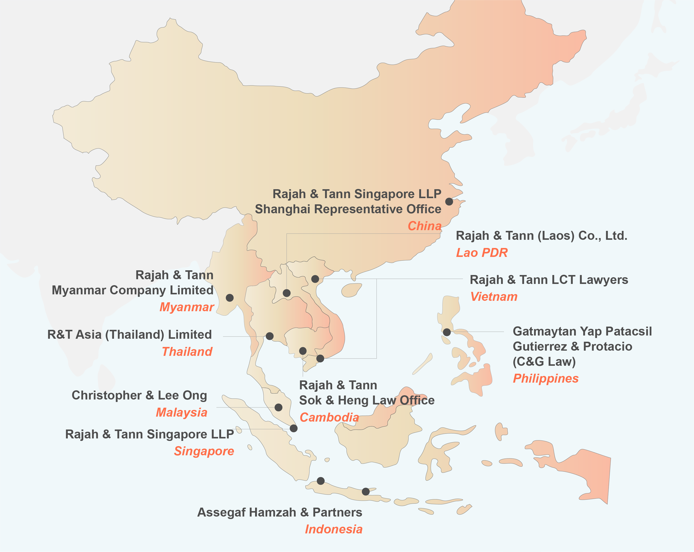

Rajah & Tann Singapore LLP is one of the largest full-service law firms in Singapore, providing high quality advice to an impressive list of clients. We place strong emphasis on promptness, accessibility and reliability in dealing with clients. At the same time, the firm strives towards a practical yet creative approach in dealing with business and commercial problems. As the Singapore member firm of the Lex Mundi Network, we are able to offer access to excellent legal expertise in more than 100 countries.

Rajah & Tann Singapore LLP is part of Rajah & Tann Asia, a network of local law firms in Cambodia, China, Indonesia, Lao PDR, Malaysia, Myanmar, the Philippines, Singapore, Thailand and Vietnam. Our Asian network also includes regional desks focused on Brunei, Japan and South Asia.

The contents of this Update are owned by Rajah & Tann Singapore LLP and subject to copyright protection under the laws of Singapore and, through international treaties, other countries. No part of this Update may be reproduced, licensed, sold, published, transmitted, modified, adapted, publicly displayed, broadcast (including storage in any medium by electronic means whether or not transiently for any purpose save as permitted herein) without the prior written permission of Rajah & Tann Singapore LLP.

Please note also that whilst the information in this Update is correct to the best of our knowledge and belief at the time of writing, it is only intended to provide a general guide to the subject matter and should not be treated as a substitute for specific professional advice for any particular course of action as such information may not suit your specific business and operational requirements. It is to your advantage to seek legal advice for your specific situation. In this regard, you may call the lawyer you normally deal with in Rajah & Tann Singapore LLP or email Knowledge Management at eOASIS@rajahtann.com.